

**Lab No. 08**

Mehran University of Engineering and Technology Shaheed Zulfiquar Ali Bhutto Campus, Khairpur Mir’s Department of Software Engineering

**Course: Operating System SW-225 (Practical) - Instructor: Engr. Shamshad Naveed**

Objective: Creating Ghost Installation and working with Utility Software

|  |  |  |  |  |
| --- | --- | --- | --- | --- |
| **Name:** | **Mohammad Saleem** | **Roll Number:** | | **K20SW033** |
| **Score:** | **Signature:** | **Date:** | **11/10/2022** | |

|  |  |  |  |  |  |  |  |
| --- | --- | --- | --- | --- | --- | --- | --- |
| **LAB PERFORMANCE INDICATOR** | SUBJECT KNOWLEDGE | DATA ANALYSIS AND INTERPRETATION | ABILITY TO CONDUCT EXPERIMENT | PRESENTATION | CALCULATION AND CODING | OBSERVATION  /RESULTS | SCORE |
|  |  |  |  |  |  |  |  |

Task :

**Step 01:** Format your USB in this format and click on start

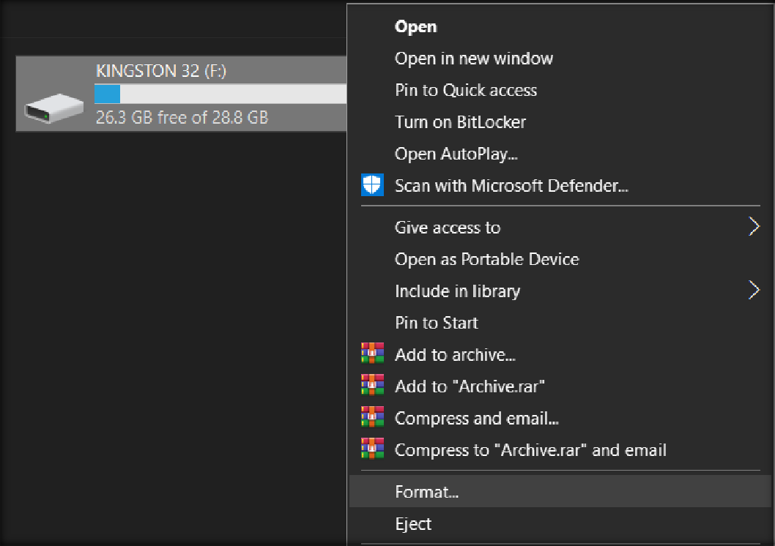

**Step 02:** Click on **“Start”** and click on **“Ok”**

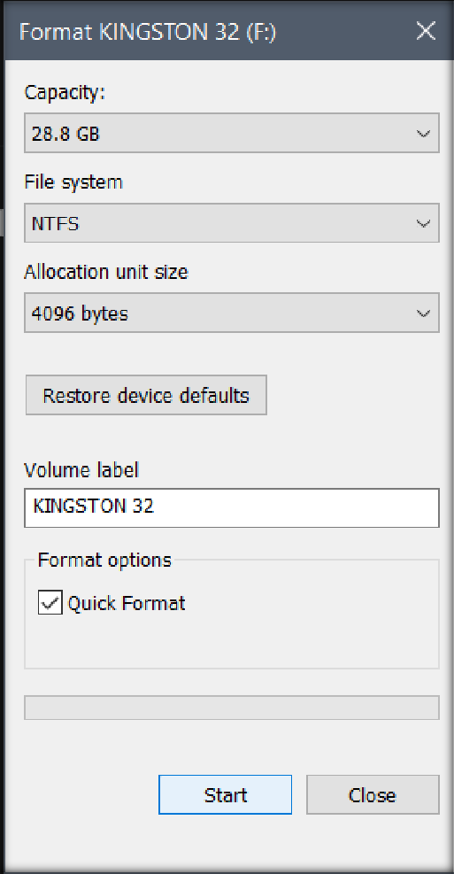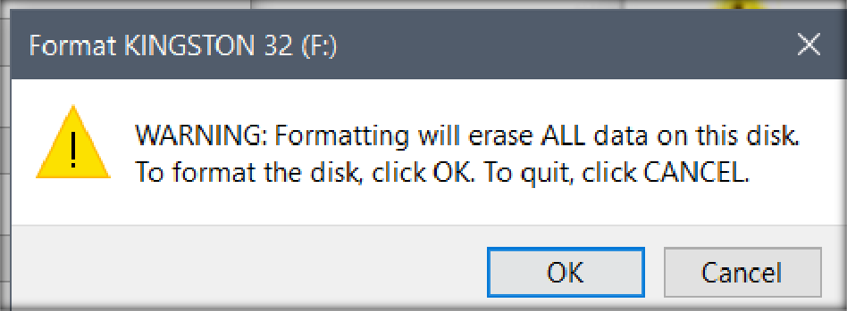

Again click on “Ok”

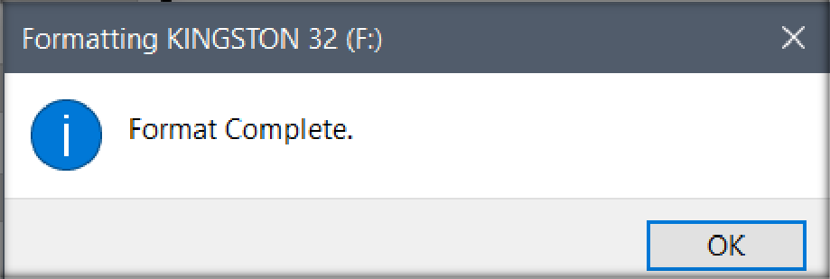

**Step 03:** Open your **“Format USB Tool”** and click on **“Run as Administrator”**

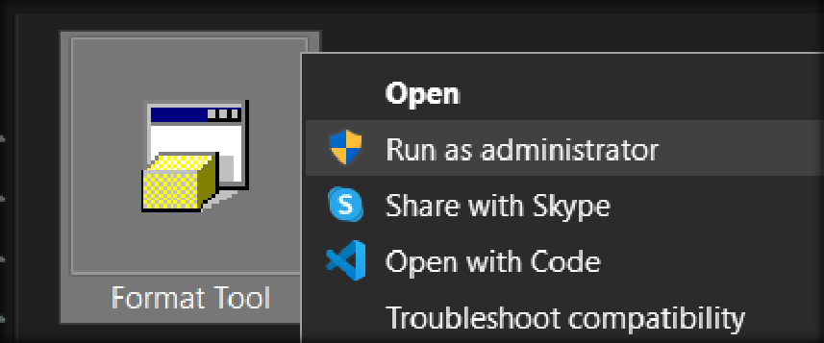

**Step 04:** Now make your **USB** in this format and click on **Start**

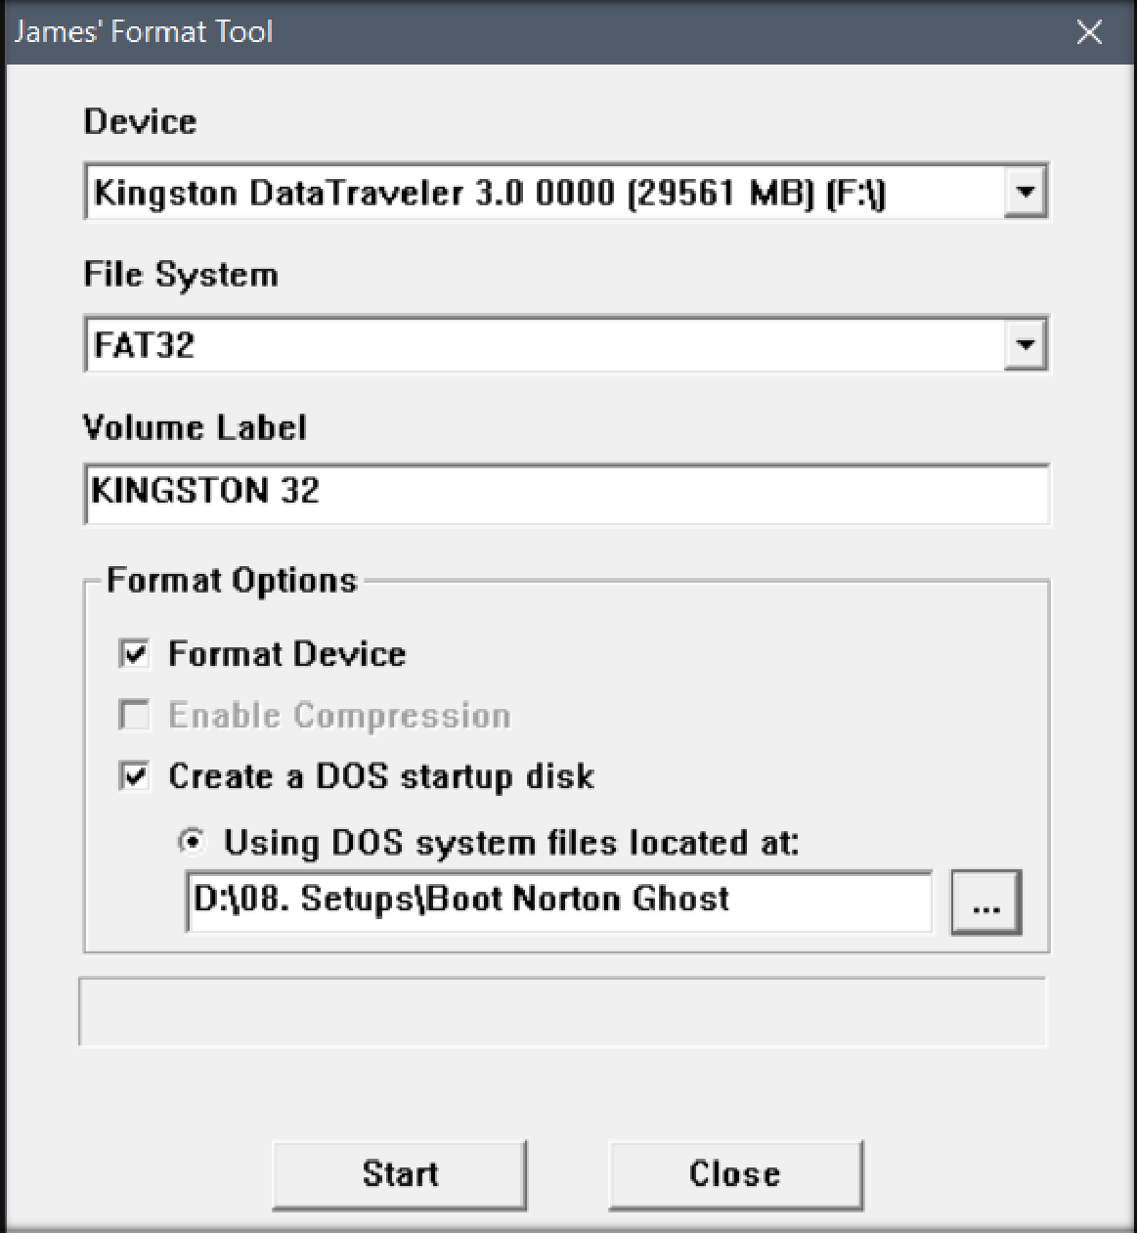

**Step 05:** Click on **Yes**

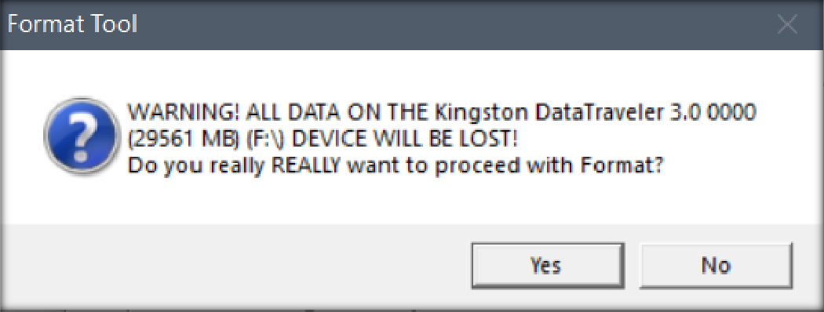

**Step 06:** Click on **Ok**

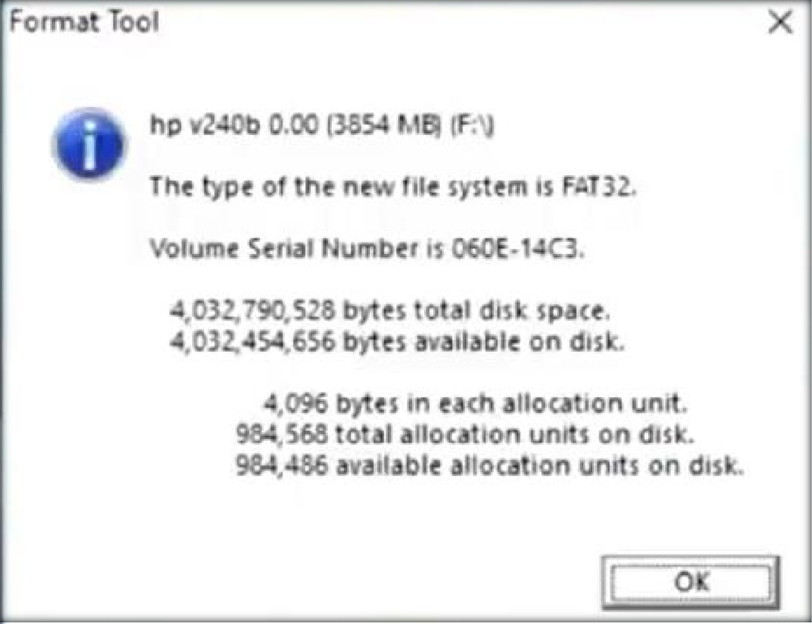

Step 07: Now copy all these files from Boot Norton Ghost and paste these in

your USB

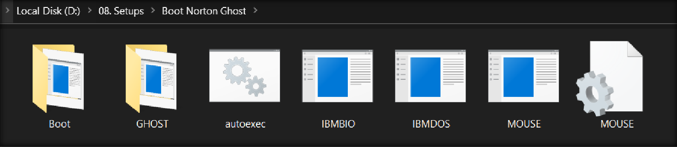

**Step 08:** Now **Restart** your PC and go to your **Boot option**

**Step 09:** Now select your **boot device** the process will start itself

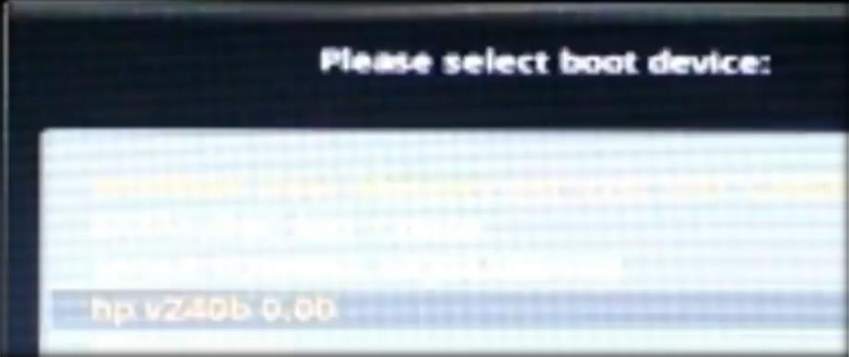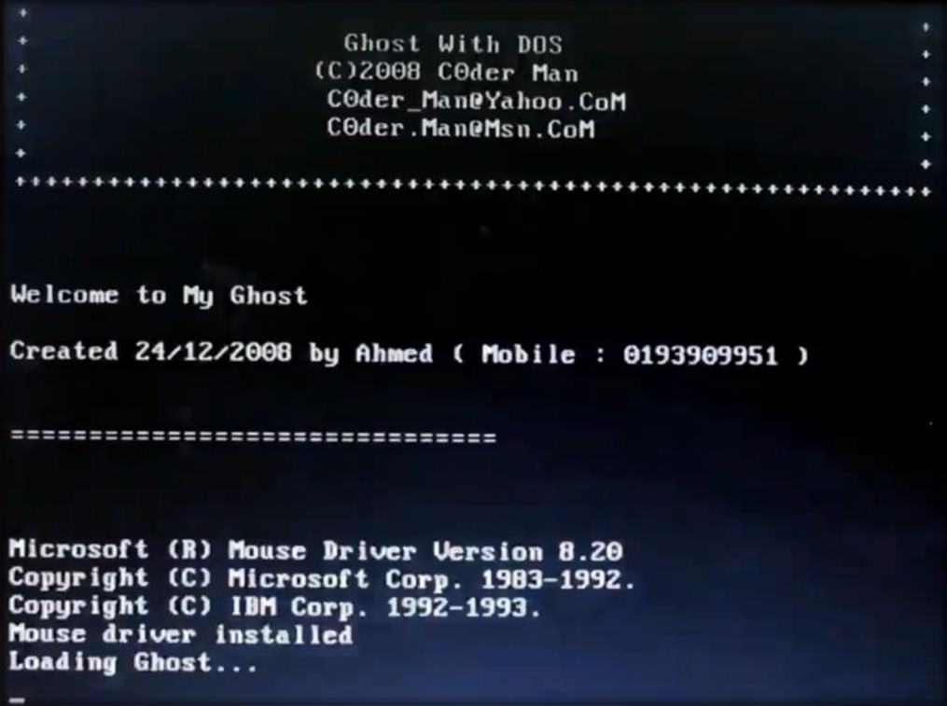

**Step 10:** After opening this window click on **Ok**

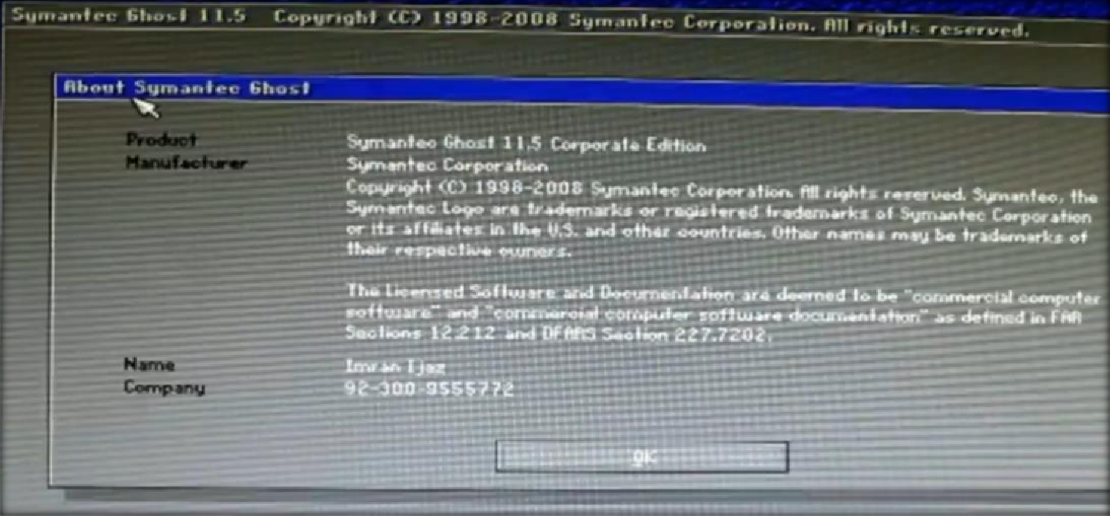

Step 11: Now right click then click on Local then click on Partition then click on To Image

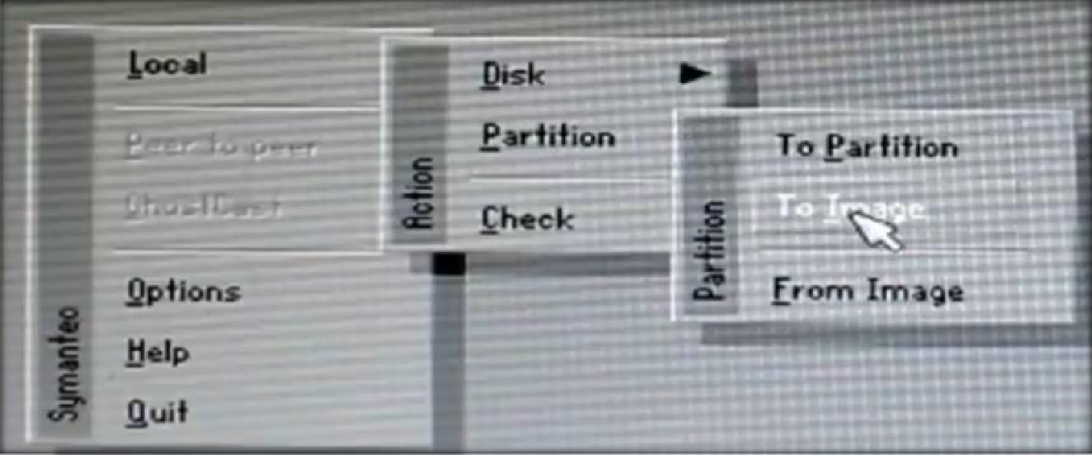

**Step 12:** Now select you **Storage Disk and click on Ok**

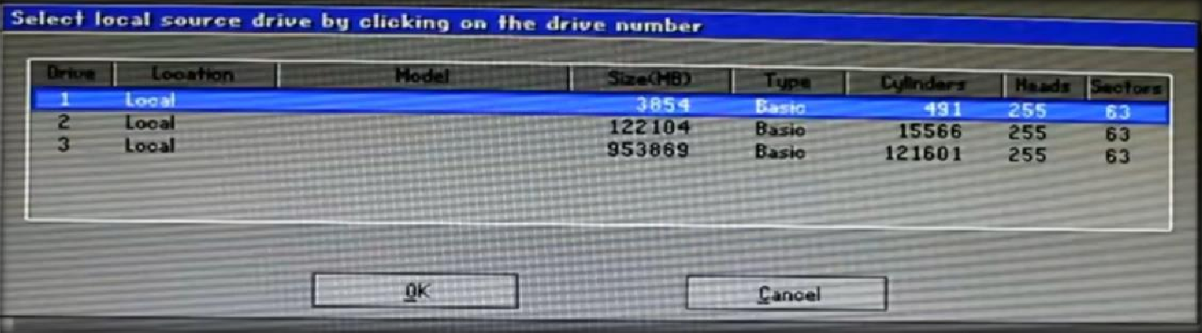

**Step 12:** Now select **NTFS and click on OK**

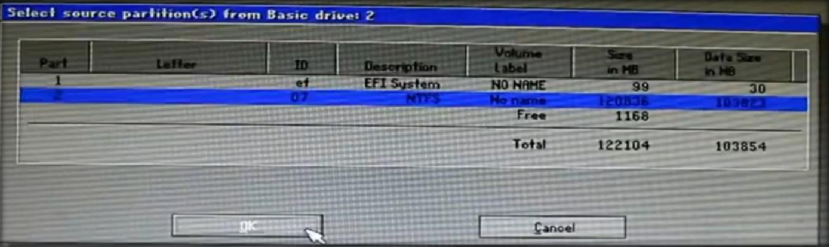

**Step 13:** Now click on **No**

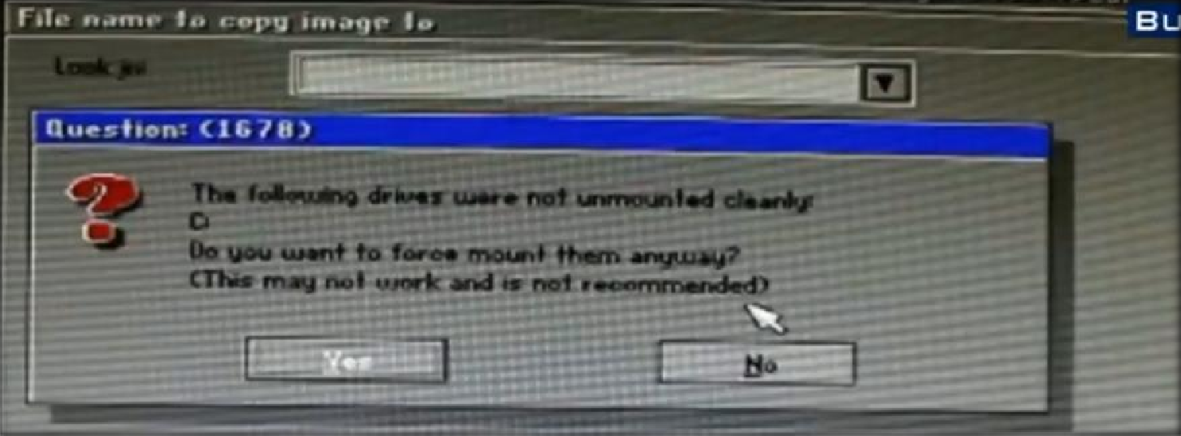

**Step 14:** Now select your **FAT Drive**

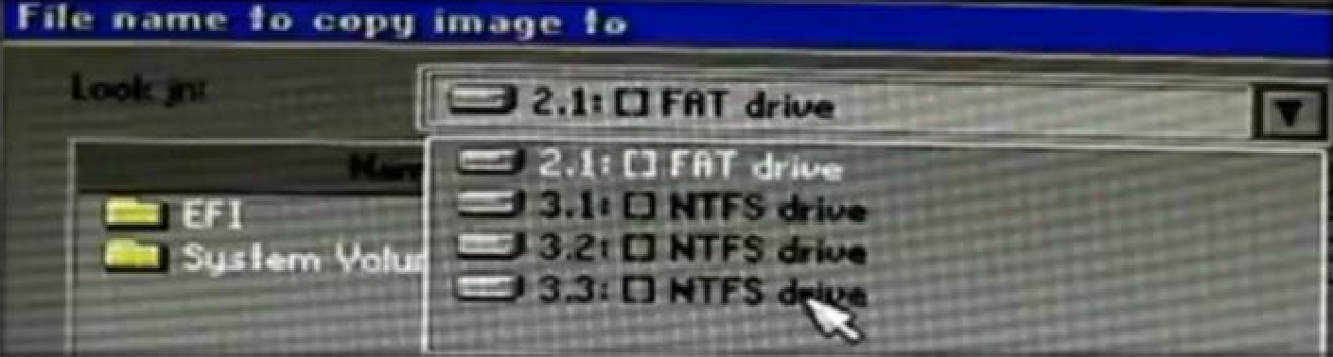

Step 15: Now give file name and click on save

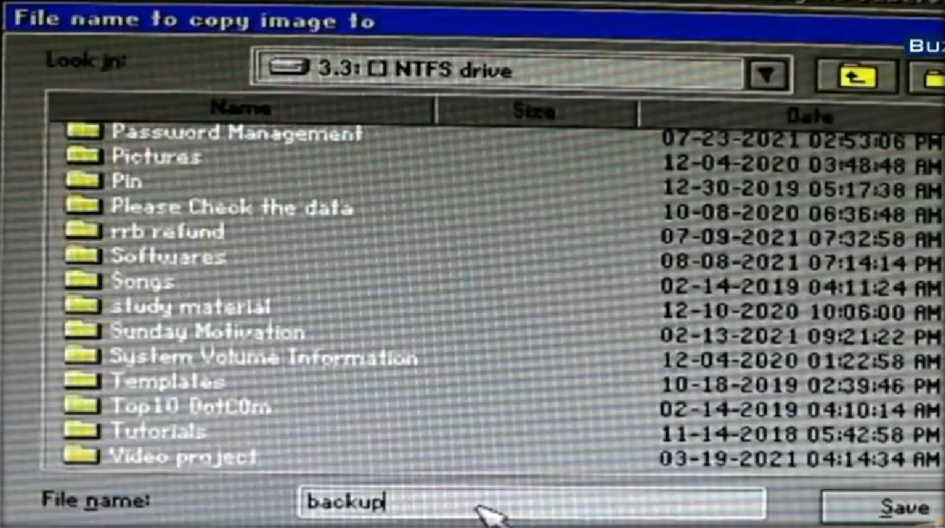

**Step 16:**

Click on **Fast**

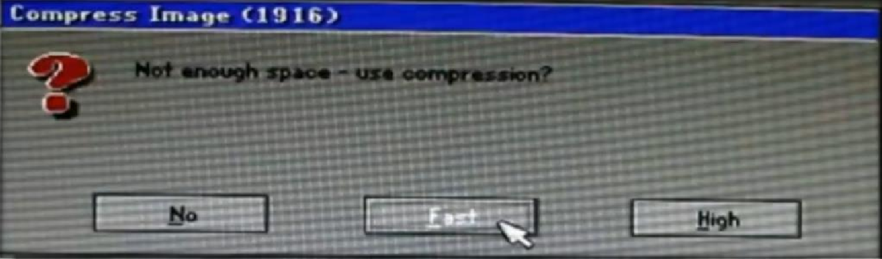

**Step 17:** Process will start itself after completing process click on **Continue**

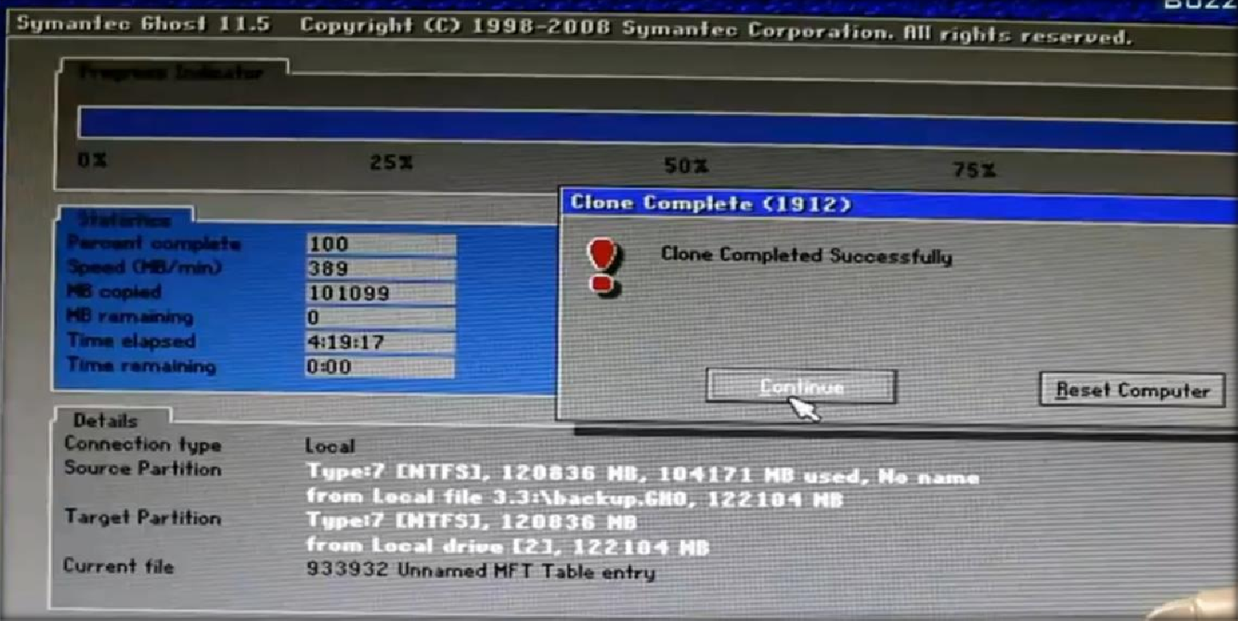

Step 18: Right click and after that click on Quit

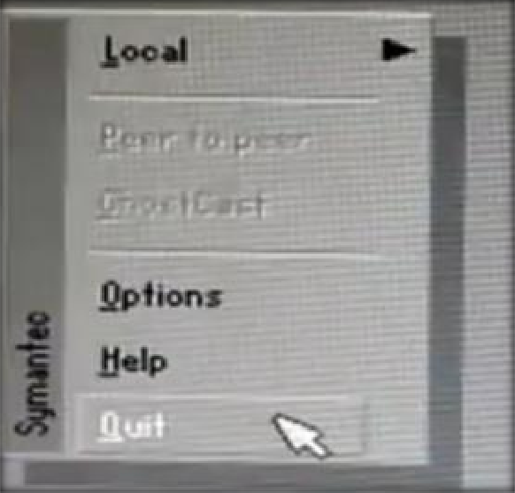

Now here is Our Ghost image of our files

